Purpose / Scope:
Timing and action plan to run every product, process, tool and gauge change at KTX Toccoa in PLM2, including changes controlled by KTX Weissenburg. Standards: IATF 16949 8.5.6, 8.5.6.1, 8.3.6, 7.5.3; VDA 6.3 P2; VDA 2.
Owner / involved:
- C. Demmler, Process Development: owner of PLM2 and of every action in this plan, author, keeps it current
- Program Management and APQP: support (specification, tests, pilots on the running projects, evidence)
- Departments named per action (IT, Quality, Development, Tooling, HR, department heads): support where their part is needed
- Plant Management: monthly status review
1. Summary
The change process is built and running in PLM2. What remains is testing with the departments and tightening the role model, so that every step is done by the right function only. Go-live, meaning every new change at TOC runs in PLM2 only, is 12/21/2026.
2. Requirements and how they are met
Requirement | How it is met | What we show
Documented change process, risk analysis before implementation (8.5.6, 8.5.6.1) | Fixed stages; routed departments assess with an impact checklist and typed risks; not feasible stops the change | Assessment tab of any change
Customer approval before implementation (8.3.6.1, 8.5.6.1) | Hard gate for customer changes: valid offer accepted plus PM and Quality sign-off before approved; internal changes need PM cost approval | Offer tab, sign-off record
Verification / validation of the change (8.5.6) | Validation stage with department checks, a 16-item release checklist and validation issues (8D, escalation L1-L3) | Release tab
Records and traceability (7.5.3) | Every action in a hash-chained audit trail; documents filed per stage | Changelog of the change
Changes from the mother plant | Weissenburg side track: impact lock by Development and read-and-understood receipts before approval | CR-2026-0001..0003 (G6X)

3. Process flow
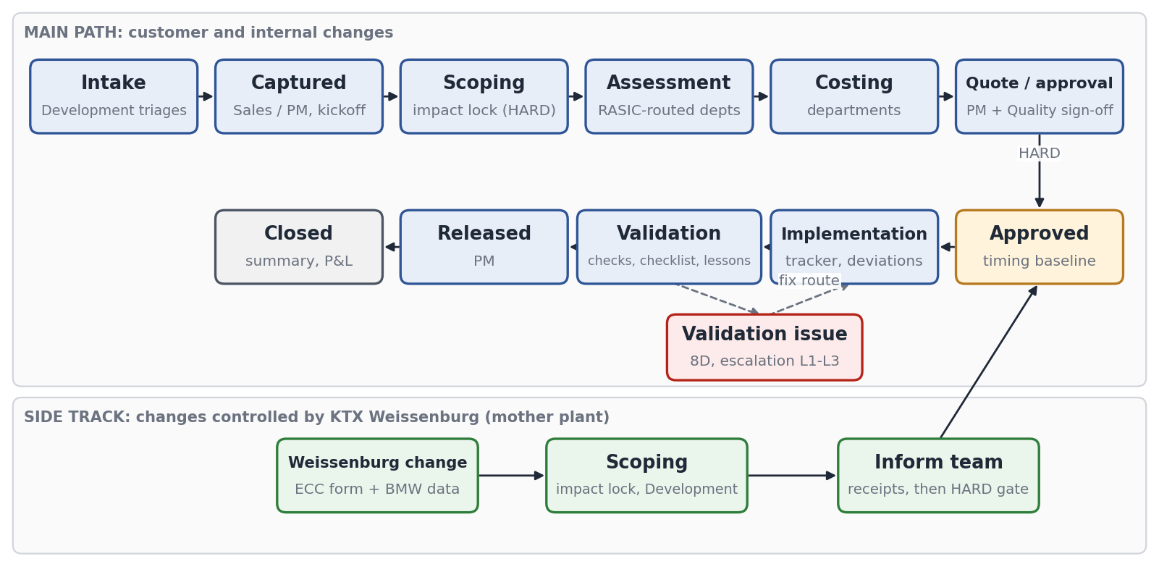
- Hard gates cannot be overridden by anyone: impact lock before assessment, customer acceptance with PM and Quality sign-off before approval, and for Weissenburg changes impact lock plus team informed.
- Soft guards (kickoff, timing validated, release checklist) can only be passed with a documented, approved deviation.
- Routing (R/A/S/C per department) is set at scoping; a department added later needs a reason and a second approver.
4. Timing planner and tasks
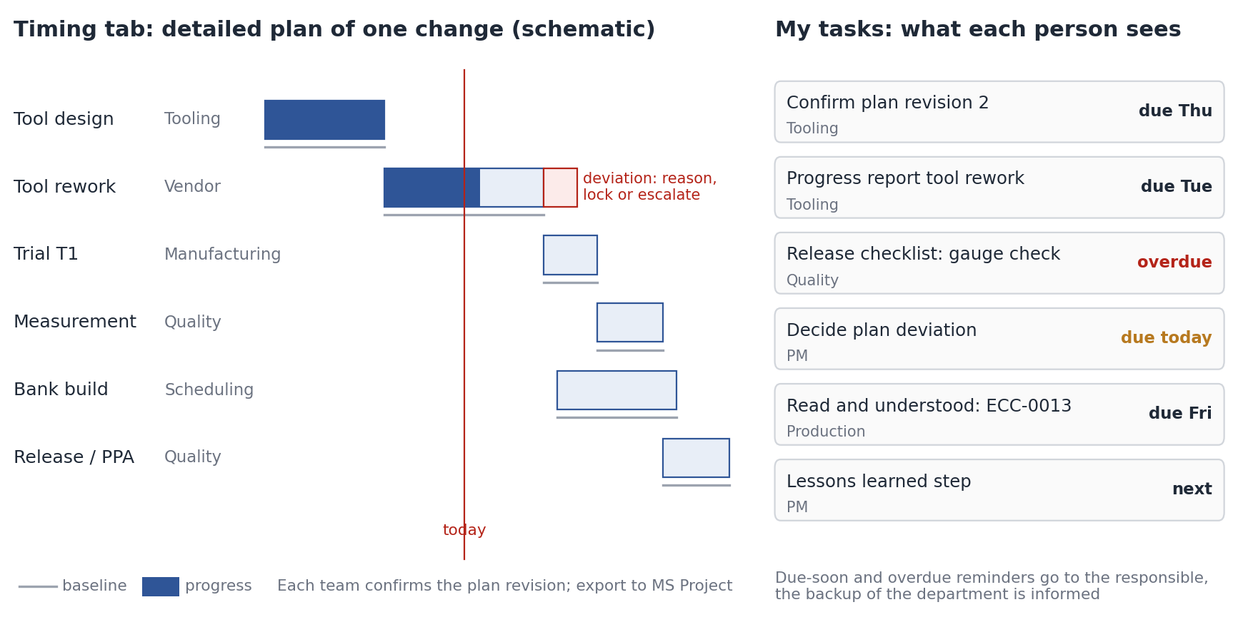
- Timing planner: every approved change gets a detailed plan with blocks per department and vendor. Each responsible team confirms the plan revision; 'timing validated' sets the baseline. Export to MS Project for the customer.
- Tracking: progress and actual dates per block, regular progress reports. After the baseline every date move is a deviation with a reason, accepted internally or escalated to the customer through Sales.
- Tasks: every person sees their own open tasks (confirm plan, answer assessment, report progress, release check, decide deviation, read and understood) with due dates in 'My tasks' and a next-step checklist on the change.
- Reminders: due-soon and overdue tasks and deadlines at risk are notified automatically; the project team has one responsible per role and a backup.
5. Where we stand today
Element | Status | Evidence in PLM2
Stages captured to closed, internal branch | Built | Lifecycle and gates in every change record
Assessment, costing, offer, negotiation | Built | Assessment, Costing and Offer tabs
Timing planner, baseline, deviations, tasks | Built | Timing tab, My tasks
Release checklist, lessons step, validation issues | Built | Release tab
Weissenburg side track | Built, in use | G6X changes CR-2026-0001..0003 from the ECC list
Department rights per function | Tightening | Actions E1-E3
Acceptance test with all departments | Testing | Actions T1-T2

6. Tightening points
Today | Tightening measure | Action | Due
Edit rights are broad: most editors hold the admin role | Rights per department from the company directory groups; admin only for IT and the system owner | E1 | 11/13/2026
Internal cost approval allows the requester to approve | Strict four-eyes on every approval and sign-off | E2 | 11/06/2026
Training is recorded but not required | Only trained users can act on a stage (training gate on) | E3 | 11/20/2026
Changes also kept in SharePoint ECC list and Excel form | PLM2 is the record from go-live; list frozen read-only | F3 | 12/21/2026

7. Timing and action plan
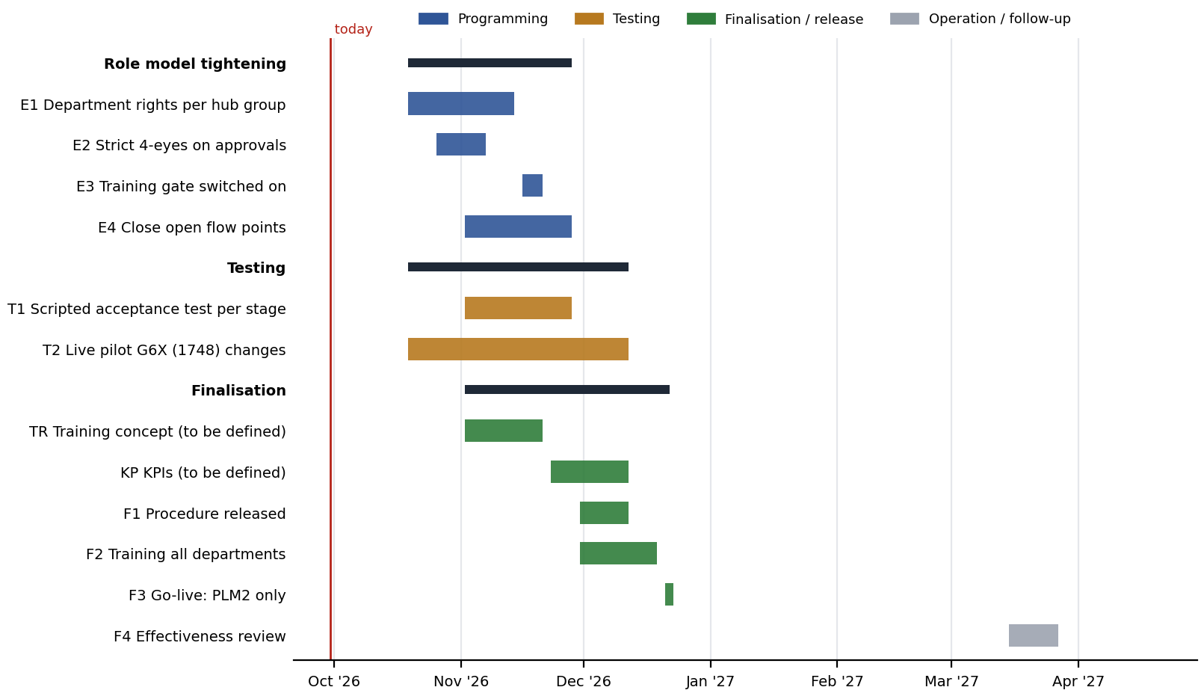
No. | Action | Phase | Owner | Support | Due | Done when
E1 | Department rights from directory groups; admin role limited to IT and system owner | Programming | C. Demmler | IT | 11/13/2026 | Rights matrix filed; test log per role
E2 | Strict four-eyes on internal cost approval and sign-offs | Programming | C. Demmler | Program Mgmt., APQP | 11/06/2026 | Self-approval rejected in test
E3 | Training gate switched on per stage | Programming | C. Demmler | HR | 11/20/2026 | Untrained user blocked in test
E4 | Close open flow points (cost carrier re-confirmation, impact edits after quote) | Programming | C. Demmler | Program Mgmt., APQP | 11/27/2026 | Regression suite green
T1 | Scripted acceptance test, one script per stage, signed by each department | Testing | C. Demmler | Department heads | 11/27/2026 | Signed test protocols filed
T2 | Live pilot: G6X (1748) Weissenburg changes plus the next customer change | Testing | C. Demmler | Program Mgmt., APQP | 12/11/2026 | Pilot changes complete in PLM2
KP | KPIs (open, to be defined): set targets, sources and review cycle for the change process, starting with implementation on time | Finalisation | C. Demmler | Quality, Program Mgmt. | 12/11/2026 | KPI set agreed, shown in the monthly review
F1 | Procedure 'Change management with PLM2' released | Finalisation | C. Demmler | Quality | 12/11/2026 | Procedure in document control
TR | Training concept (open, to be defined): which roles need which training per module (ECR, SEP, data, lessons), format, trainer, records | Finalisation | C. Demmler | Program Mgmt., APQP, HR | 11/20/2026 | Concept agreed with department heads
F2 | Training of all departments per training concept (TR) | Finalisation | C. Demmler | Program Mgmt., APQP | 12/18/2026 | Training records in PLM2
F3 | Go-live: new changes in PLM2 only; ECC list read-only | Finalisation | C. Demmler | Plant Mgmt. | 12/21/2026 | Announcement; list locked
F4 | Effectiveness review after three months | Operation | C. Demmler | Quality | 03/26/2027 | Review in management review

The table is the plan as of the status date above. Progress is tracked in the action plan TOC-PLM-LOP (KTX LOP F-DVS-CORP-010); a date that moves is changed there with the reason, and this document is updated with it.
8. Control until go-live
Until 12/21/2026 the Weissenburg form GB-CM-0001 and the SharePoint ECC list stay valid. Every change they hold for TOC is also opened in PLM2 with the form filed on it, so the PLM2 record is complete from the first day of the pilot.
9. Effectiveness indicators
Indicator | Target | Source
Changes run outside PLM2 after go-live | 0 | ECC list (read-only) vs PLM2
Changes released with open validation issue | 0 | Release tab
Changes past release deadline | Trend down, reviewed monthly | Change list, deadline state
Overdue tasks at monthly review | Trend down | My tasks / notifications
Changes implemented on time (implementation date met) | To be defined (action KP) | Change list, implementation deadline vs actual

The KPI set beyond these indicators is to be defined (action KP): targets, data source in PLM2 and the review cycle are agreed with Quality and Program Management before go-live.

